**DATE : 15-NOV-2022**

**TEAM ID : PNT2022TMID33663**

**PROJECT TITLE : IoT BASED SMART CROP PROTECTION SYSTEM FOR AGRICULTURE**

**TEAM MEMBERS: BALAJI N, AGATHIYAN S, KEERTHIRAJAN A, KAVIN R.**

Develop A Web Application Using Node-RED Service.

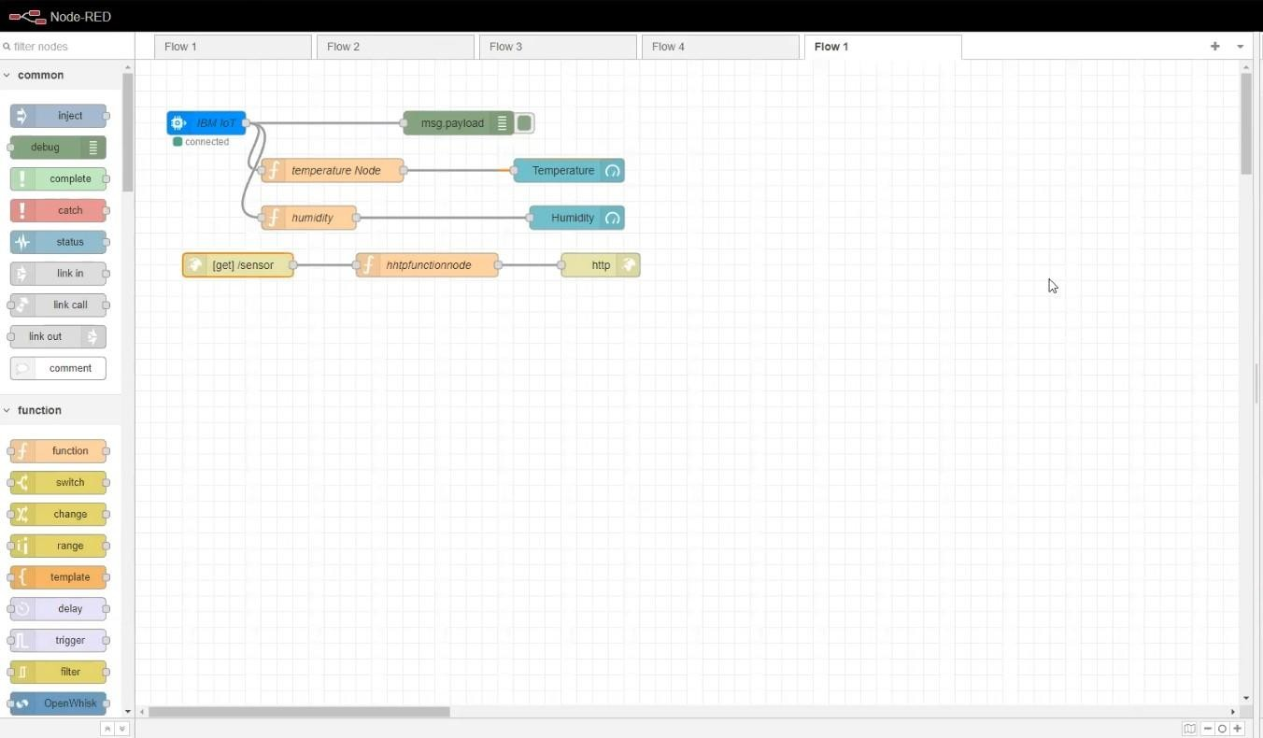

FIGURE-1

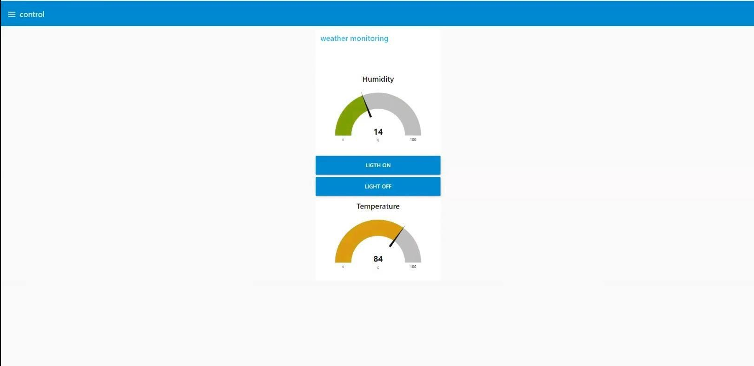 FIGURE 2